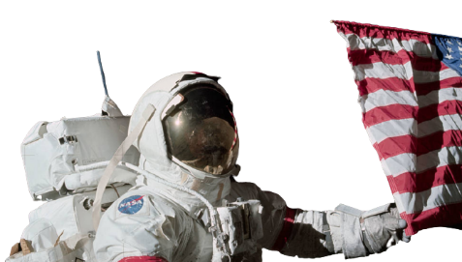

Manned Space Mission to the Moon and the Mars
GENERAL
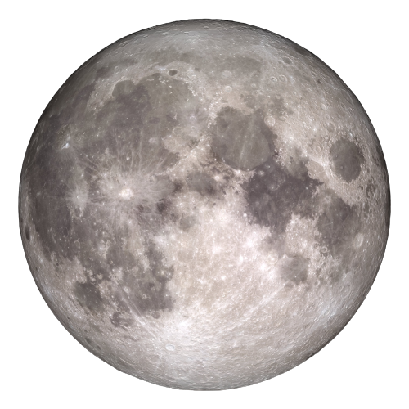
Manned space missions to the Moon and Mars have been the focus of space exploration for decades. These missions present significant challenges, including the development of technology to support human life in space, the duration and hazards of long-duration spaceflight, and the cost and logistical challenges of such ambitious undertakings.

NASA
NASA is the abbreviation for the name of the U.S. space agency. The initial letters of National Aeronautics and Space Administration are now an independent term. The civilian U.S. federal agency for aeronautics and space was founded in 1958.

APOLLO 3 AND THE FUTURE
Using the gigantic Space Launch System mega rocket and Orion spacecraft.
For landing on the moon, the crew will use SpaceX's Star ship, a system that the California company is developing right now for crewed human missions.

Artemis 3 will be the US space agency's first crewed Moon landing mission since Apollo 17 in 1972.

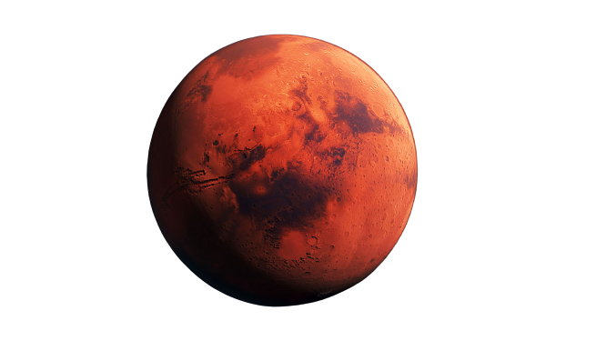
However, NASA's long-term goals are even more ambitious: using the technology and research developed during the Artemis flights, NASA intends to launch a future crewed mission to Mars.
This 'Moon to Mars' plan involves building a new space station in lunar orbit and, eventually, a habitable Moon base.
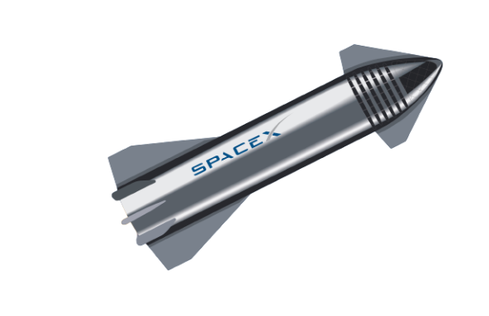
SpaceX
SpaceX is an American spacecraft manufacturer, launcher, and
a satellite communications corporation headquartered in Hawthorne,
California. It was founded in 2002.
by Elon Musk with the stated goal of
reducing space transportation costs to enable the colonization of Mars.

Artemis


The Artemis program is a manned space project of NASA in cooperation with international partners. The goal of the program is to land astronauts on the moon for the first time since Apollo 17, including a woman for the first time.

“THAT’S ONE SMALL STEP FOR MAN, ONE GIANT LEAP FOR MANKIND.”
Neil Armstrong

